Name: Sujitha S

Branch: BE CSE

Dataset Collection and Preparation (Weeks 1–2):

Week 1(Day 1)

I started the project and looked for good sources of satellite and drone images. I used Google Earth Pro and OpenAerialMap. I also decided the labels: Ruins, Vegetation, Artifacts, and Background Terrain. I checked which areas to focus on and noted some small challenges like shadows and unclear spots.

Websites Used:

[Google Earth Pro](https://www.google.com/earth/versions/earthpro)

[OpenAerialMap](https://openaerialmap.org)

Week 1(Day 2)

I explored the dataset platforms in more detail and checked the type of imagery they provide. I compared the resolution, terrain visibility, and clarity of different websites to understand which sources are most suitable for ruins, vegetation, and artifact analysis. I also reviewed how these images can be used later for annotation and model training. This helped me understand the strengths of each website and plan which datasets to download next.

Websites Checked:

OpenAerialMap:

<https://openaerialmap.org/>

Google Earth Pro (Download page)

<https://www.google.com/earth/about/versions/>

Week 1(Day 3)

Start identifying exact locations to collect images for each label (Ruins, Vegetation, Artifacts, Background Terrain).

### **What I did :**

* I selected a few specific locations from the websites I explored earlier.
* I focused on places where ruins and vegetation are clearly visible from satellite images.
* I checked each location on Google Earth Pro to see the clarity and zoom level.
* I marked areas that are suitable to download later for annotation and model training.
* I also noted which labels (Ruins, Vegetation, Artifacts, Background Terrain) appear clearly in each location.

### **Locations I checked :**

**Ruins:**

* Hampi, Karnataka
* Mahabalipuram, Tamil Nadu
* Angkor Wat, Cambodia

**Vegetation:**

* Western Ghats, India
* Amazon Forest region
* Nilgiri Hills

Week 1(Day 4):

**Task: Image Collection + Start Labeling**

Today I downloaded more images from the websites I used earlier (OpenAerialMap, Google Earth Pro, Earth Explorer). I focused on getting clear pictures that show ruins, vegetation areas, and possible artifacts. After collecting the images, I began labeling them using an annotation tool. I created separate labels like “Ruins”, “Vegetation”, and “Artifacts” so they can be used later for training YOLO or SSD models.

**What I did Today:**

* Collected extra images from different terrains
* Selected the clearest ones for training
* Started labeling using polygon and bounding-box tools
* Used three labels: **Ruins, Vegetation, Artifacts**
* Saved both the original images and the labeled images

**Files I uploaded:**

* Raw images
* Labeled images (mask/box)

U-Net:

a specialized Convolutional Neural Network (CNN) architecture, shaped like the letter 'U', designed for image segmentation, where it classifies every pixel in an image.

Vegetation: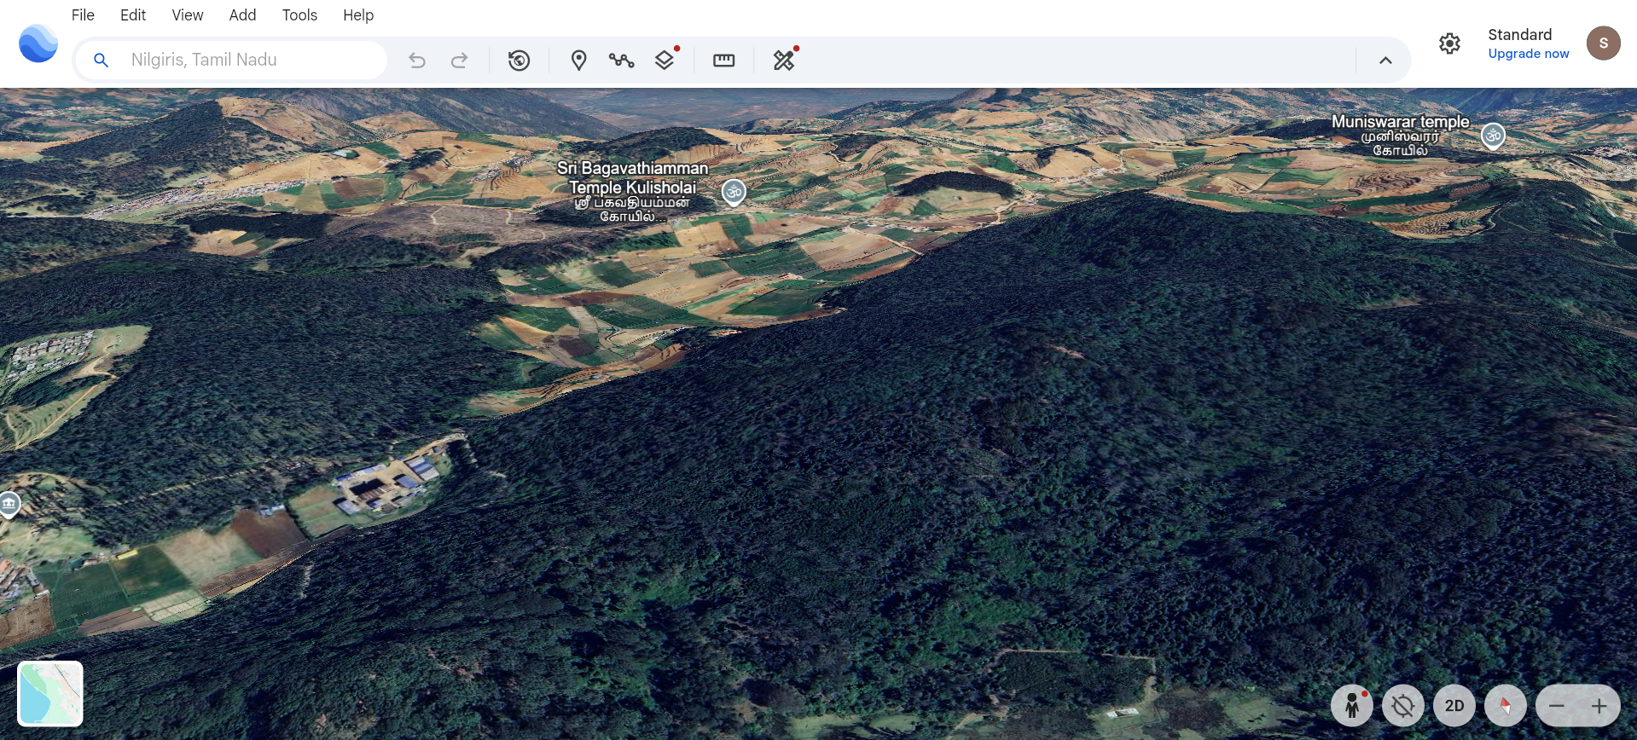

Ruins:

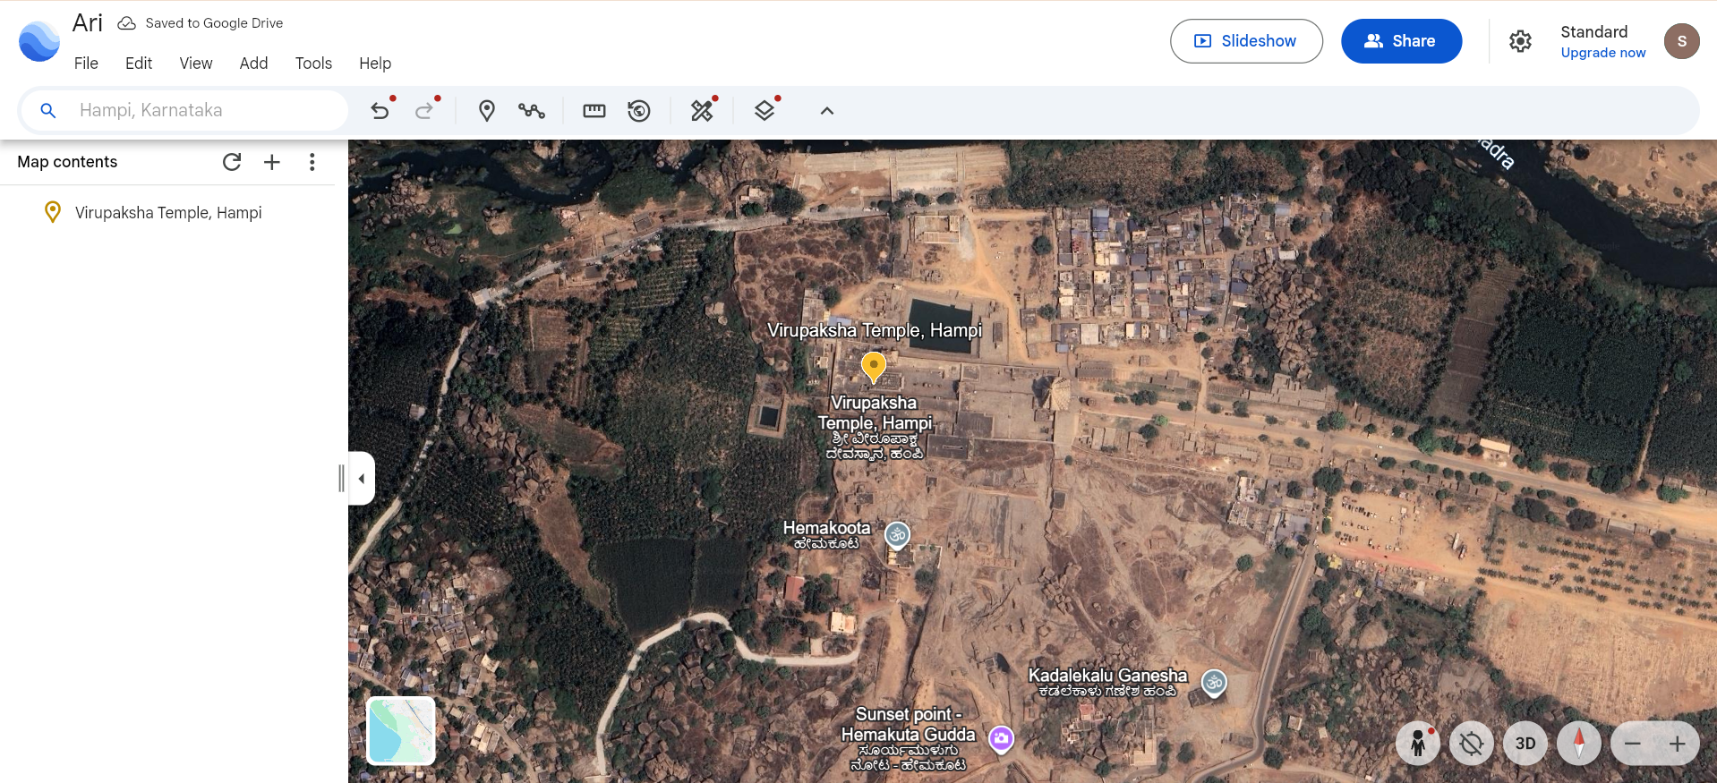

Artifact:(img from google)

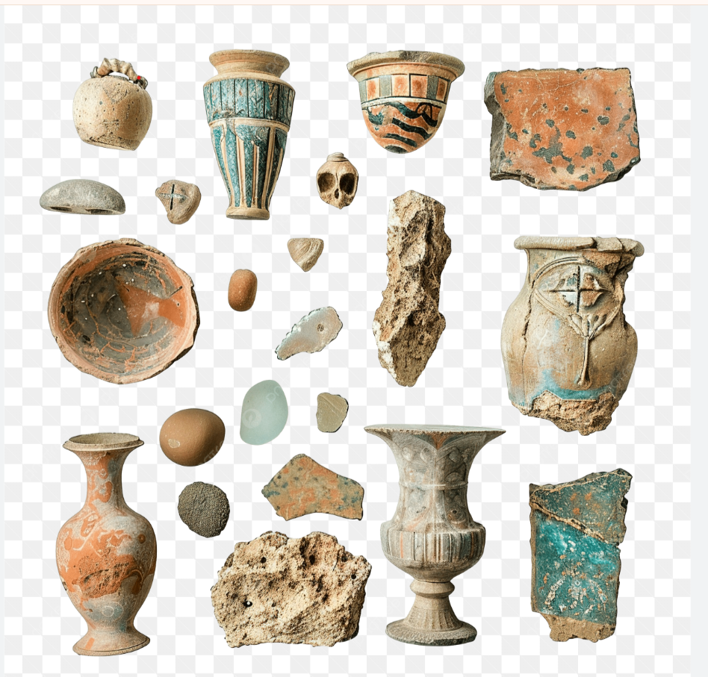

Week 1(Day 5):

### **Task: Completed Labeling + Added Roboflow Dataset + U-Net Preparation**

Today I finished labeling the images I collected earlier. I uploaded them into **Roboflow**, created labels for **Ruins**, **Vegetation**, and **Artifacts**, and generated a clean dataset version for training. Along with labeling, I also reviewed how **U-Net segmentation** will work on my dataset and prepared the images for future pixel-wise segmentation.

## **✔ What I Did**

* Uploaded the raw images into **Roboflow**
* Created bounding-box annotations for  
   **Ruins**, **Vegetation**, **Artifacts**
* Exported/organized the dataset for model training
* Viewed Roboflow’s auto-generated model API
* Studied U-Net one level deeper (not too advanced)
* Prepared my dataset so it can be used for segmentation in future weeks

Labeled images:

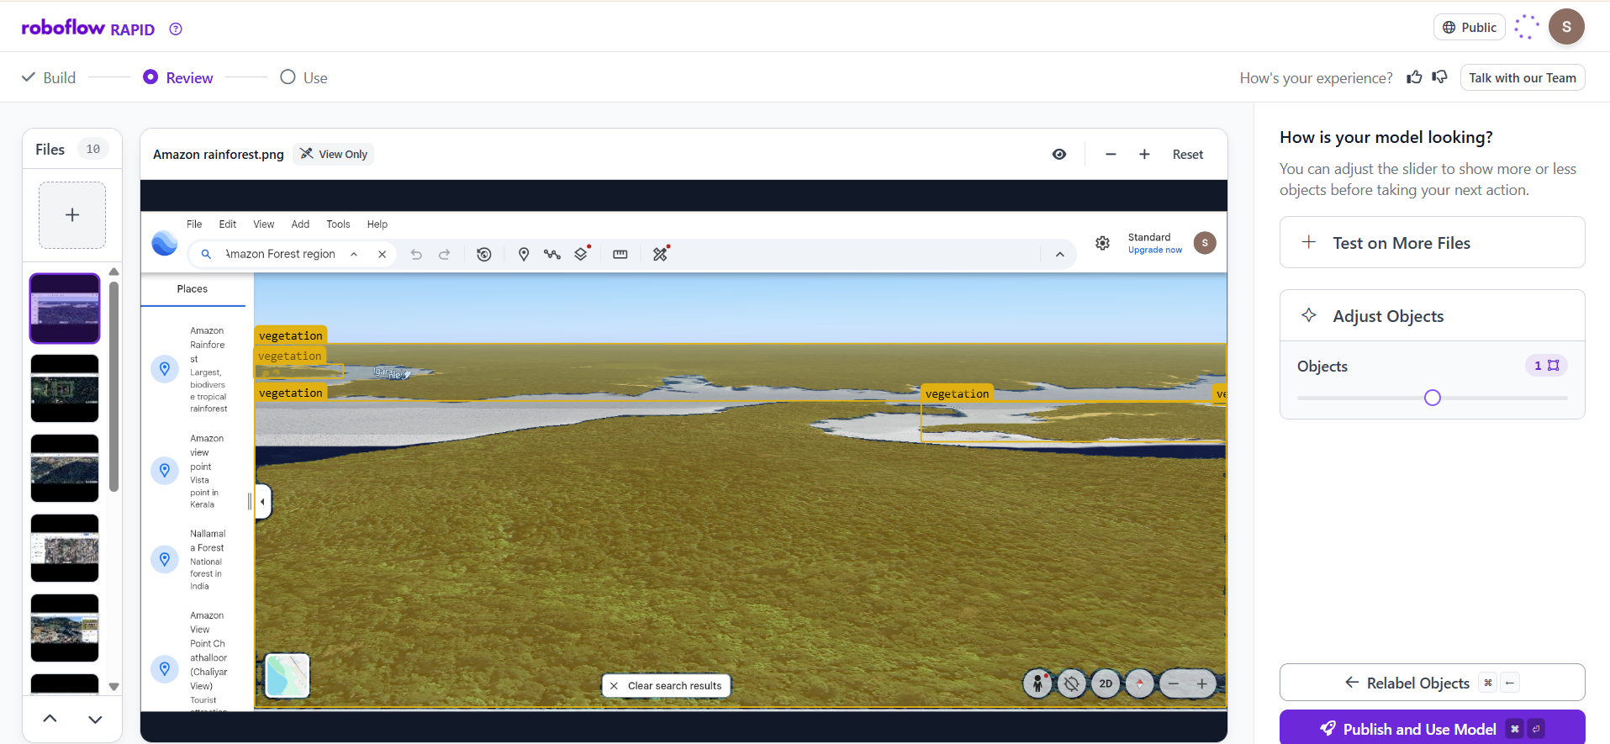

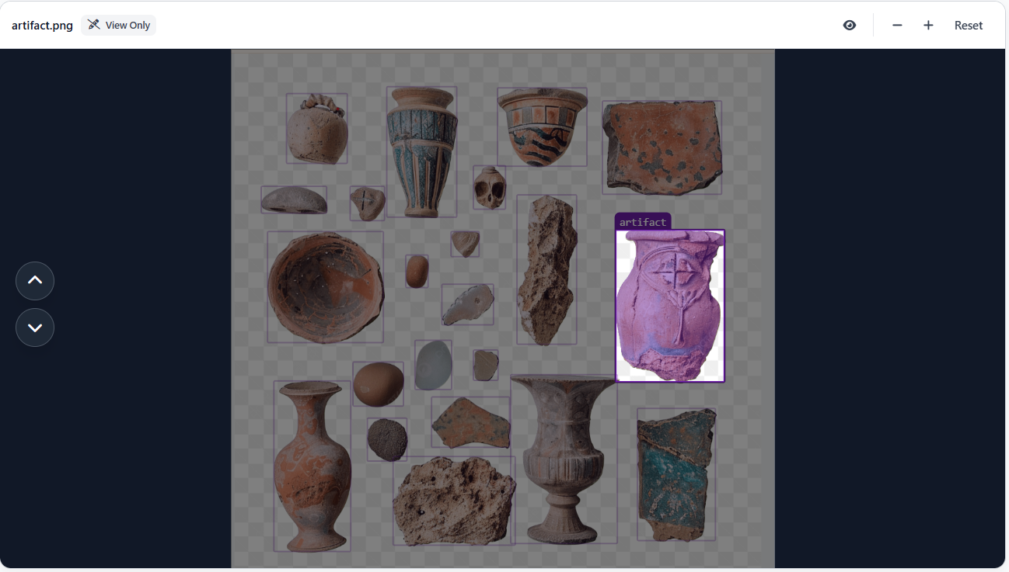

### Workspace Link:

<https://rapid.roboflow.com/projectinfosys/models>

### Direct Build:

<https://rapid.roboflow.com/projectinfosys/build/prompt>

Week 2(Day 1):

**Dataset Augmentation and Segmentation Preparation**

**Task:** Combine Roboflow dataset, explore CVA.ai, and prepare images for segmentation using U-Net.

**What I Did :**

* Accessed the dataset uploaded and labeled in **Roboflow** last week.
* Explored **CVA.ai** for dataset visualization and image pre-processing.
* Prepared the dataset for **U-Net segmentation** by aligning images and masks for pixel-wise classification.
* Selected **6 example images** for each label to show progress.

**Screenshots / Example Images with YOLO Annotations:**

1. **Labeled Image**
   * Image: *( image from Make Sense)*
   * YOLO Annotation: 0 x_center y_center width height

**Observations / Notes:**

* Dataset is now ready for segmentation model training.
* Roboflow export makes it easy to use the dataset with U-Net.
* CVA.ai can be used later for feature extraction and model evaluation.
* Ongoing: Train a basic **U-Net** model and check segmentation accuracy.

**Websites / Tools Used:**

* <https://roboflow.com/>
* <https://www.makesense.ai/>
* <https://www.cva.ai/>

Label img(from makesense.ai)

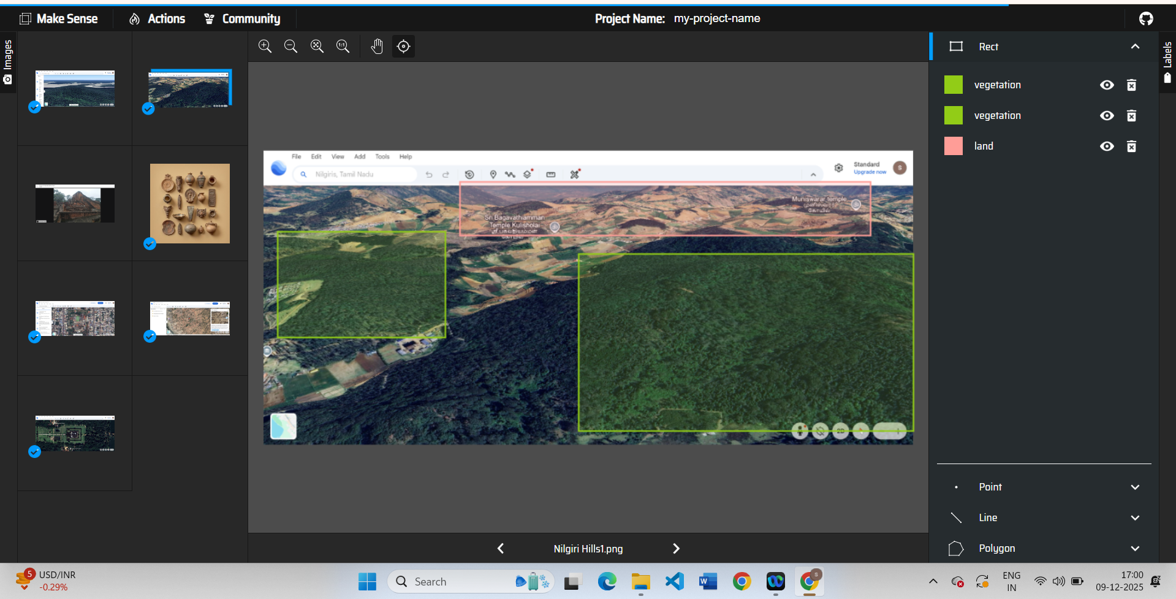

YOLO annotation values:

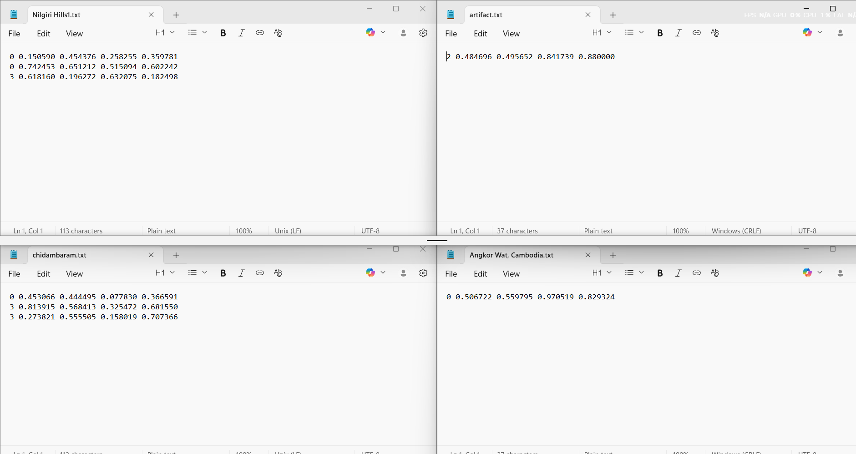

Week 2(day 2)

notebook referred (from kaggle):

Satellite Images Semantic Segmentation by U-Net

<https://www.kaggle.com/code/stpeteishii/satellite-images-semantic-segmentation-by-u-net/notebook>

## **Understanding and Running U-Net + YOLOv5 (Basics)**

### **U-Net Segmentation:**

* I selected a Kaggle notebook about **U-Net Image Segmentation**.
* I downloaded the notebook and executed it in **Spyder (Python)**
* U-Net is a deep learning model shaped like **U**.
* It takes an image and predicts **a mask** for every pixel.

# **Week 2 ( Day 3 )**

* Learned the core concepts used in image segmentation models like U-Net and YOLO.
* Understood how images are converted into tensors and processed by deep learning frameworks.

## **Key Concepts**

### **1. Tensor**

A **tensor is a multi-dimensional array** used to store image and mask data for models.

### **2. TensorFlow**

A **deep learning framework by Google** used for building and training neural networks.

### **3. PyTorch**

A **deep learning framework by Meta** known for flexibility and easy model development.

### **4. Normalization**

A process that **scales pixel values (0–255 → 0–1)** so models learn faster and more accurately.

### **5. unsqueeze()**

An operation that **adds one extra dimension** to a tensor so the model can read it correctly (example: adding a channel dimension).